Project Plan

|  |  |
| --- | --- |
| Student Name | Agung Yuda Pratama |
| Student ID | BDSE07-0922-076 |
| Centre Name | Lithan EduClaas |
| Mentor | Arvinder Kaur |
| Date | 05-09-2023 |
| Qualification Name | Applied Degree in Software Engineering  Higher Diploma in Software Engineering |
| Milestone | Project Plan |
| Module Name (BDSE) | Capstone Project – Application Development |
| Project Title |  |

1. **Introduction**

The research proposal outlines our plan to enhance the customer experience for Jumpstart, a retail chain with 750 stores nationwide. The retail landscape has evolved, and in the wake of post-COVID-19 challenges, Jumpstart aims to reshape its business model by focusing on customer experience. We aim to leverage technology to provide a seamless, personalized, and engaging shopping experience, ultimately increasing customer satisfaction, loyalty, and revenue while optimizing operational efficiency.

**2.0 Scope**

The scope of this project includes:

* We are developing an E-commerce website with responsive design, interactive product presentation, and consistent UI design.
* We are implementing technology solutions to enable 24/7 access for customers.
* Enhancing the overall customer experience through promotions, discounts, and free delivery options.
* We conduct surveys and research to gather insights into customer preferences and behaviors.

**3.0 Objectives**

The objectives of this project are designed to address the core challenges faced by Jumpstart and to deliver measurable outcomes that positively impact the company's performance:

1. **Enhance Customer Satisfaction:**

The primary objective is to elevate customer satisfaction by creating a seamless, personalized, and engaging shopping experience through the newly developed E-commerce website. By ensuring accessibility around the clock, customers will be free to explore and make purchases whenever and wherever they desire.

1. **Increase Customer Loyalty:**

By offering compelling promotions, discounts, and free delivery options on the E-commerce platform, the project aims to increase customer loyalty. This enhanced loyalty will lead to repeat purchases, stronger brand relationships, and a heightened attachment to Jumpstart's offerings.

1. **Drive Revenue Growth:**

Through the improved customer experience delivered by the E-commerce website, the project intends to contribute to the overall revenue growth of the Jumpstart retail chain. Enhanced customer satisfaction and loyalty will translate into increased sales, conversions, and average transaction values.

1. **Optimize Operational Efficiency:**

Technology solutions and process automation will be strategically integrated to optimize operational efficiency. By reducing manual tasks and minimizing errors, these enhancements will lead to streamlined operations, reduced costs, and improved overall productivity.

In addition to these primary objectives, the project aims to conduct a feasibility study to assess the proposed solution's technical, operational, economic, and legal aspects. This feasibility study will provide important insight into the project's feasibility and help guide decision-making.

Through effective project planning, stakeholder management, resource allocation, risk mitigation, and regular evaluation, this initiative seeks to achieve its objectives and position Jumpstart as a customer-centric leader in the retail industry. By leveraging technology and prioritizing a seamless customer experience, the project endeavors to overcome the challenges posed by the post-COVID-19 landscape and create a successful pathway to sustained growth and competitiveness.

**4.0 Milestones /WBS/Gant Chart**

The following milestones will be achieved during this project:

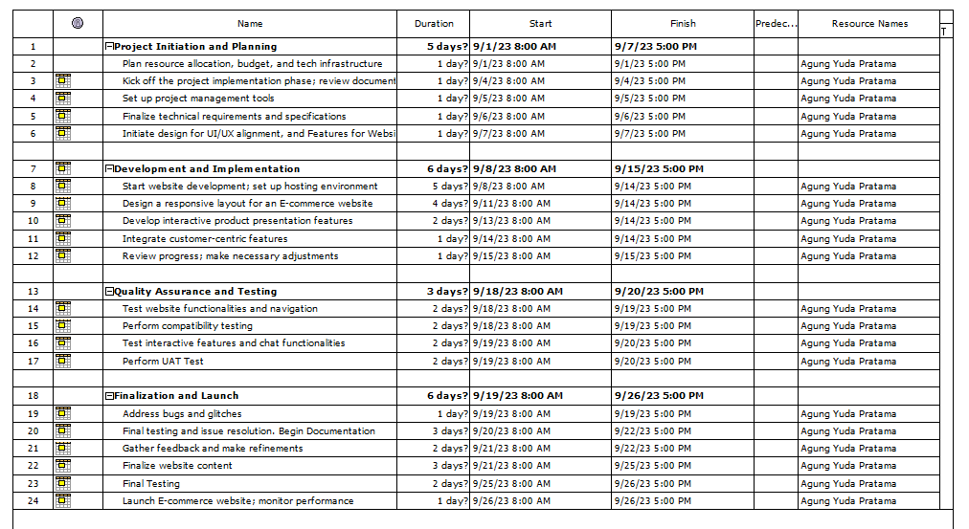

**Gantt Chart**

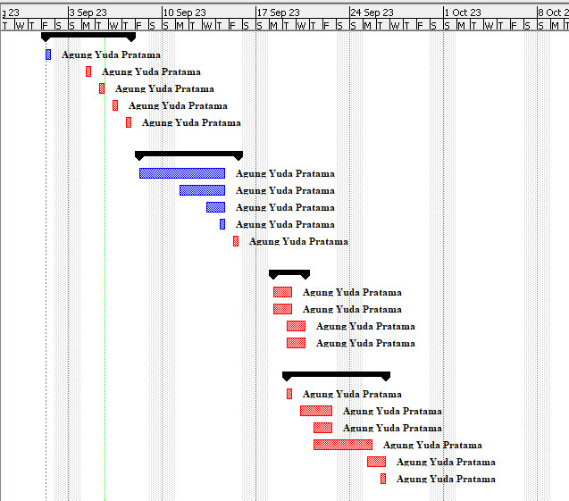

**WBS**

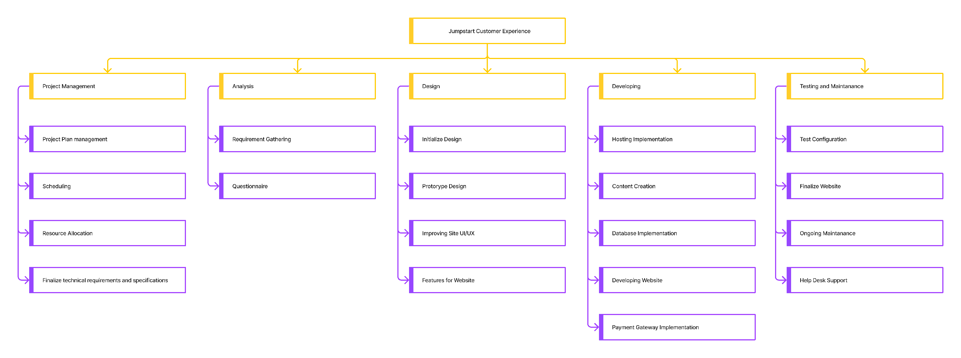

**5.0 Budget**

The following is the budget for this project:

|  |  |  |
| --- | --- | --- |
| Item | | |
| Software | * Windows 10 / 11 * CMS WordPress License Premium * Plugin License Premium | $1820 |
| Hardware | * Intel Xeon Silver 4210 2.2GHz Turbo 3.2GHz * 32 GB * 4 TB * 2TB NVMe Gen. 4 * Gigabit Network * Asus TUF VG328H1B 31.5" * Seasonic Prime Titanium TX-1000 - 1000W 80+ Titanium Certified * USB Mouse Keyboard | $9200 |
| Direct Project | * Requirement Gathering * Design and Implementation * Human Resource management | $6980 |
| Infrastructure and Ongoing Costs | * Hosting Infrastructure * Marginal/Urgent Expenses * Maintenance and Support | $3100 |
| Total Budget of Jumpstart | | $21,100 |

**6.0 Risk**

|  |  |  |  |
| --- | --- | --- | --- |
| Risk | Impact | Likelihood | Mitigation Strategy |
| Technical Issues with E-commerce Website | High | Moderate | Conduct thorough testing and quality assurance before launch. Have backup systems in place. Continuously monitor website performance. Regularly update and patch software to address vulnerabilities. |
| Resistance to Change by Employees | Moderate | Low | Provide comprehensive training and support to employees. Clearly communicate the benefits of the new system. |
| Insufficient Budget for Project | High | Moderate | Regularly review the budget and prioritize expenditures. Seek additional funding if necessary. |
| Market Saturation or Decline | High | Moderate | Continuously monitor market trends and adjust strategies accordingly. Diversify offerings and channels. |
| Technical Resource Shortage | Moderate | Moderate | Identify potential resource shortages early and have contingency plans in place, including outsourcing if necessary. |
| Software compatibility issues | High | Medium | Test software thoroughly before implementation and have a contingency plan in place |

**Testing Plan**

|  |  |  |
| --- | --- | --- |
| **Test Scenario ID** | **Test Scenario** | **Number of test cases** |
| TS001- UAT testing | Ensure the portal’s features align with course requirements and meet users’ expectations. | 5 |
| TS002-Cross Browser testing | Ensure the application works across multiple major browsers | 3 |
| TS003 – Compability Testing | Ensure the application works across multiple devices | 3 |
| TS004- Performance Testing | Testing the performance of the application | 5 |

**Scenario 1: UAT Testing**

|  |  |  |  |  |
| --- | --- | --- | --- | --- |
| Test Scenario ID | Test Case | Risk | Test Objective | Expected Result |
| TS001 | UAT001 | 5 | Identify whether the user can successfully register or not. | Upon registration, they can use the registered credentials to authenticate to the User to System. |
| UAT002 | 5 | Identify whether the user can log in to the website with registered credentials. | Upon attempt of authentication, users will be authenticated to the website. |
| UAT003 | 5 | Identify whether the user can can do product searching and filtering | When user has log in, they can search the product and filter the product |
| UAT004 | 5 | Identify whether the user can can manage their cart | The user can add new product. It will save on cart and can delete the product on cart. |
| UAT005 | 5 | Identify whether the user can can select the payment gateway and checkout | The user can select the payment gateway, fulfill the forms and checkout the product |

**Scenario 2: Cross Browser Testing**

|  |  |  |  |  |
| --- | --- | --- | --- | --- |
| Test Scenario ID | Test Case | Risk | Test Objective | Expected Result |
| TS002 | CB001 | 3 | Identify if the Result Website works as intended on Google Chrome. | The look and feel are working as intended on Google Chrome. |
| CB002 | 3 | Identify if the Result Website works as intended on Microsoft Edge. | The look and feel are working as intended on Microsoft Edge. |
| CB003 | 3 | Identify if the result Website works as intended on Mozilla Firefox. | The look and feel are working as intended on Mozilla Firefox. |

**Scenario 1: Compability Testing**

|  |  |  |  |  |
| --- | --- | --- | --- | --- |
| Test Scenario ID | Test Case | Risk | Test Objective | Expected Result |
| TS003 | CO001 | 3 | Identify whether the website functionality works as intended using various platforms and Dekstop. | The website should have a responsive look and feel with a Dekstop view. |
| CO002 | 3 | Identify whether the website functionality works as intended using various platforms and Tablets. | The website should have a responsive look and feel, which scales down to a Tablet view. |
| CO003 | 3 | Identify whether the website functionality works as intended using various platforms and Mobile. | The website should have a responsive look and feel, which scales down to a mobile view. |

**Scenario 4: Performance Testing**

|  |  |  |  |  |
| --- | --- | --- | --- | --- |
| Test Scenario ID | Test Case | Risk | Test Objective | Expected Result |
| TS004 | PER001 | 2 | Identify the landing page performance is above 80% | A performance report is generated with performance expected to be above 80 – 90% |
| PER002 | 2 | Identify the product page performance is above 80% | A performance report is generated with performance expected to be above 80 – 90% |
| PER003 | 2 | Identify the cart page performance is above 80% | A performance report is generated with performance expected to be above 80 – 90% |
| PER004 | 2 | Identify the checkout page performance is above 80% | A performance report is generated with performance expected to be above 80 – 90% |
| PER005 | 2 | Identify the about us page performance is above 80% | A performance report is generated with performance expected to be above 80 – 90% |

**Database Design**

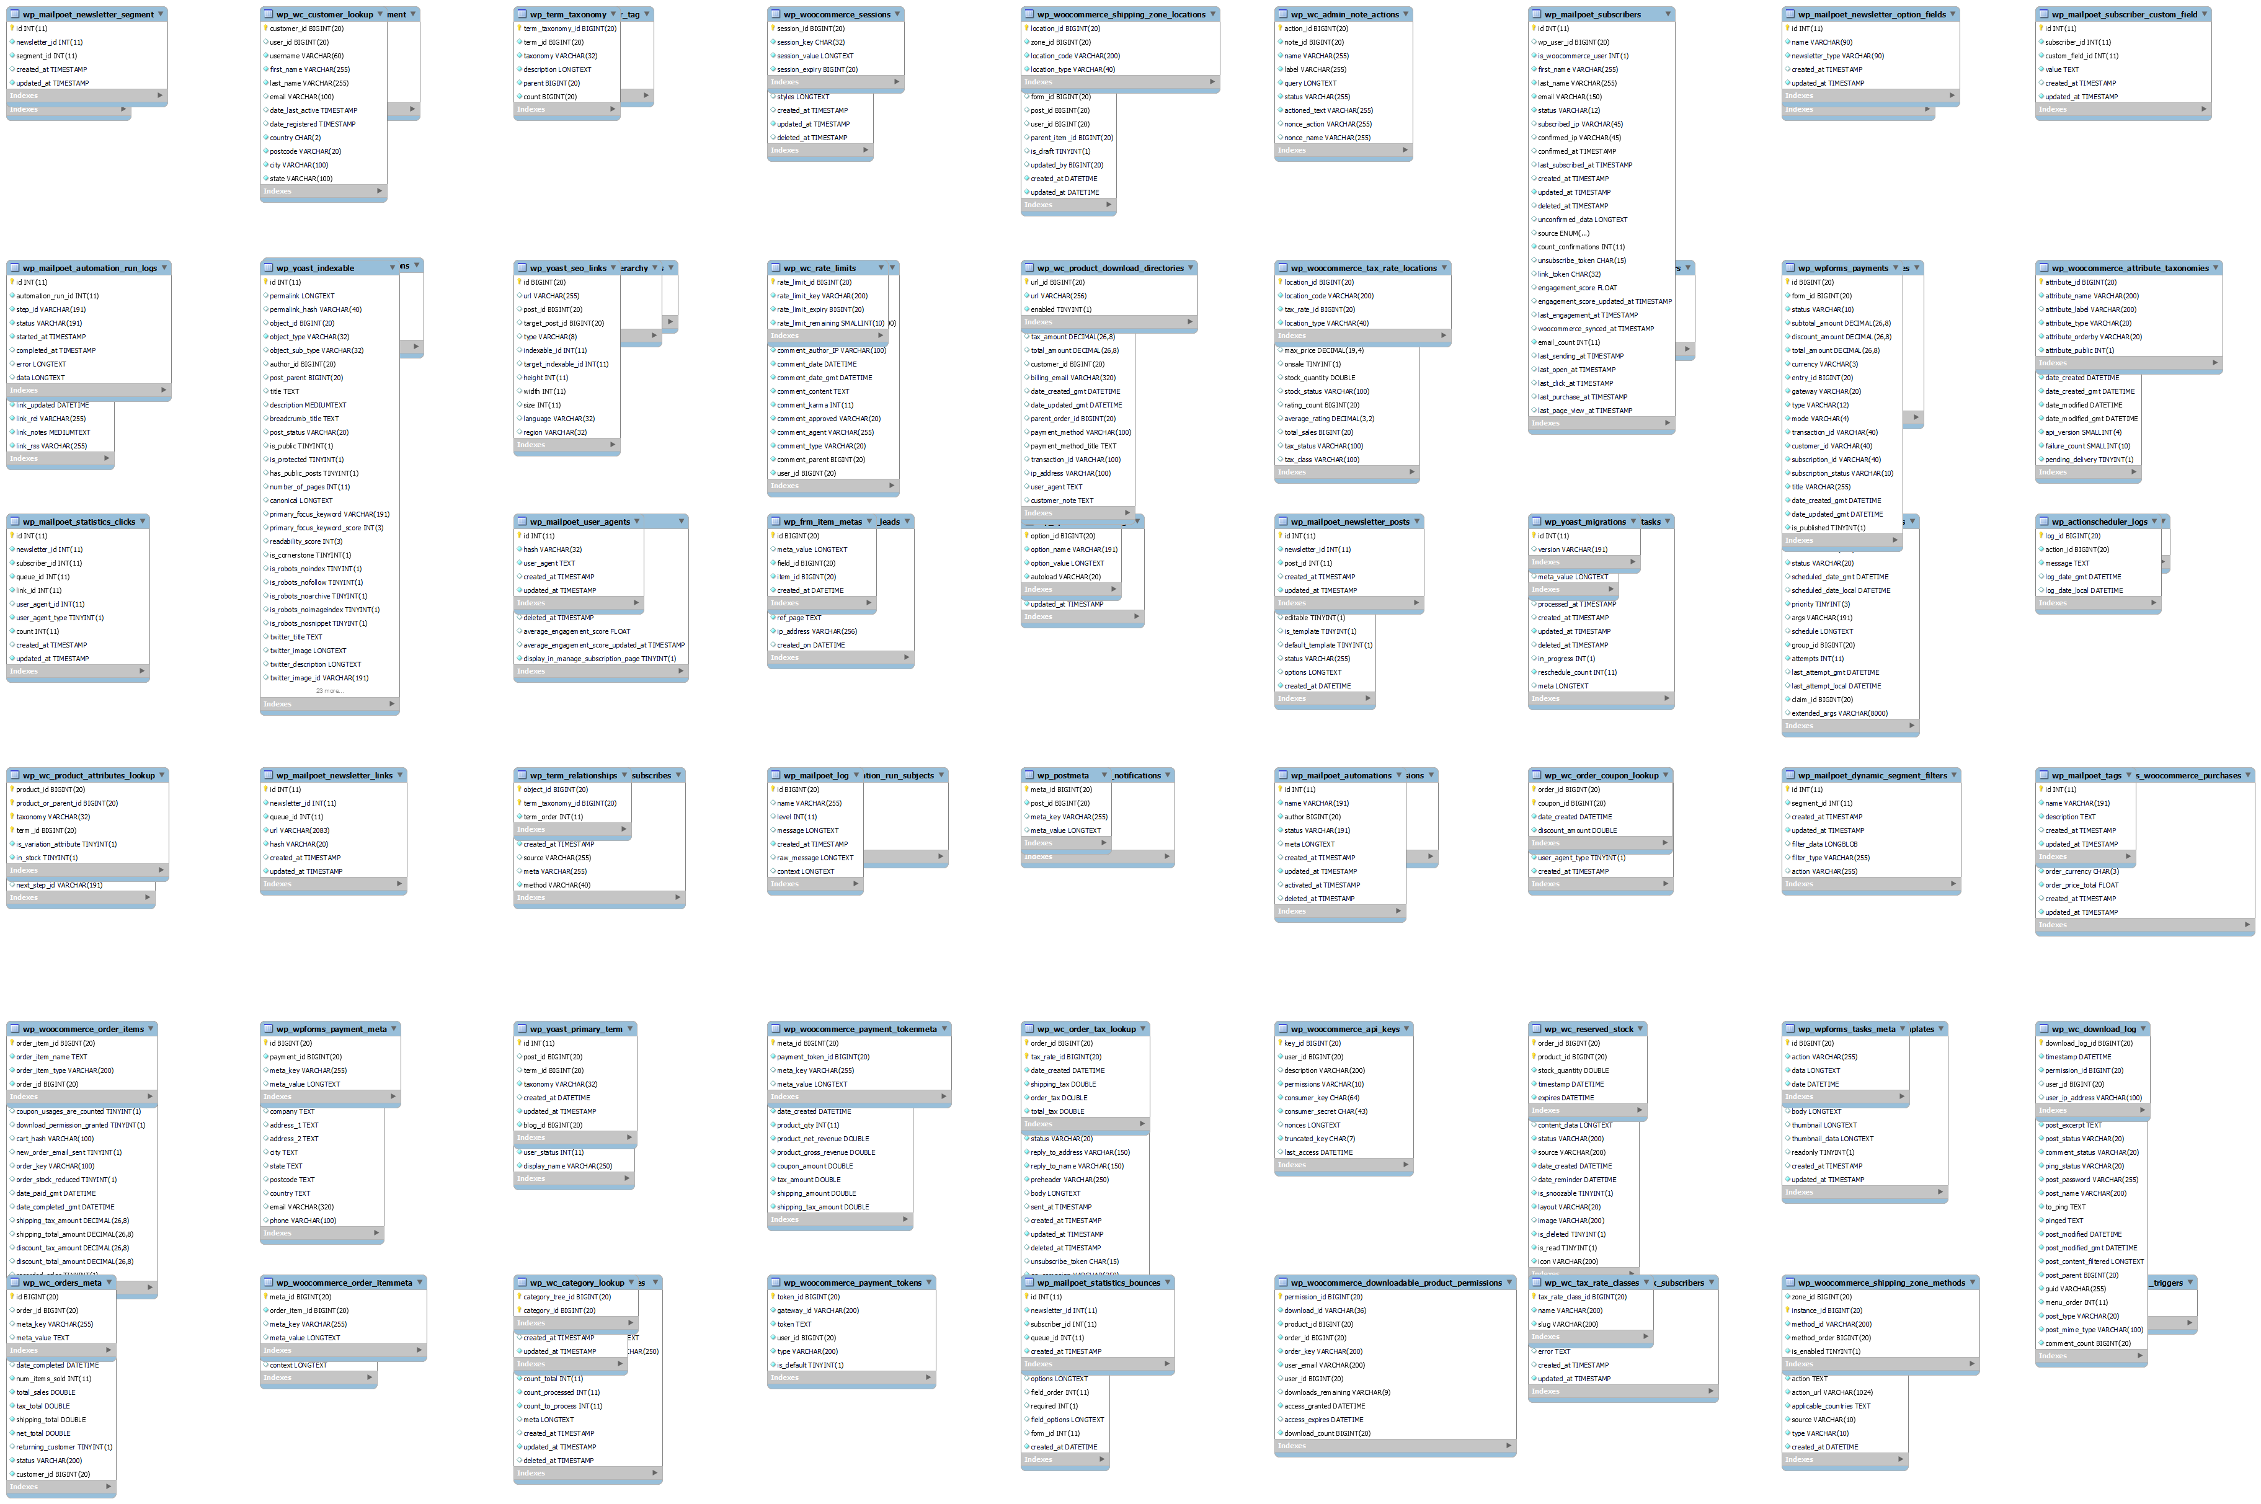

Flow Chart

